DIVISION 10 - SPECIALTIES
SECTION 10 51 13
METAL LOCKERS
CP Furniture Systems, Inc. - EVOLO LINE (S3000)

This guide specification covers the general requirements for metal lockers for storage of personal belongings.

Show the following information on the drawings:
- Location, grade and size, quantity, and color of lockers (plans).
- Trim, accessories, and adjoining surfaces details (elevations).
- Mounting details and whether legs, base panels, or pre-built bases are required (details).

**************************************************************************
- PART 1 GENERAL
**************************************************************************

  - REFERENCES
    - External References:
      - ADAAG - Americans with Disabilities Act, Accessibility Guidelines.
      - ASTM A 1008 - Standard Specification for Steel, Sheet, Cold-Rolled, Carbon, Structural, High-Strength Low-Alloy and High-Strength Low-Alloy with Improved Formability.
      - ASTM D523 – Standard test method for specular gloss (similar to ISO 2813)
      - ADA parallel reach requirements. (for maximum accessibility)
      - ADA forward reach requirements. (for narrow reach areas)
    - Related Sections
      - Section 06 10 53 - Miscellaneous Rough Carpentry for securing lockers to bases and walls.
      - 03 30 53 - Miscellaneous Cast-in-Place Concrete for locker bases.

  - SUBMITTALS
    - Comply with 01 33 00 Submittal Procedures
    - Provide manufacturer’s product data
    - Shop drawings showing plan and elevation with clearance requirements, accessories and anchoring detail
    - Provide numbering system and lock control chart
    - Three manufacturer’s standard color charts suitable for color selection

  - DELIVERY, HANDLING, AND STORAGE
    - Storage: Store materials in clean, dry, indoor areas.
    - Handling: Protect materials and finish during handling and installation to prevent damage to lockers or adjacent work.

  - FIELD MEASUREMENTS
To ensure proper fits, make field measurements prior to the preparation of drawings and fabrication. Verify correct location.

  - QUALITY ASSURANCE
Provide lockers from a manufacturer with a minimum of 10 years experience with a similar product and with an eight (8) year warranty. Install by a crew with a minimum of 10 years experience with a similar product and with a one year warranty.

1.6 ALTERNATIVES
No alternatives will be allowed or considered

**************************************************************************
- PART 2 PRODUCTS
**************************************************************************

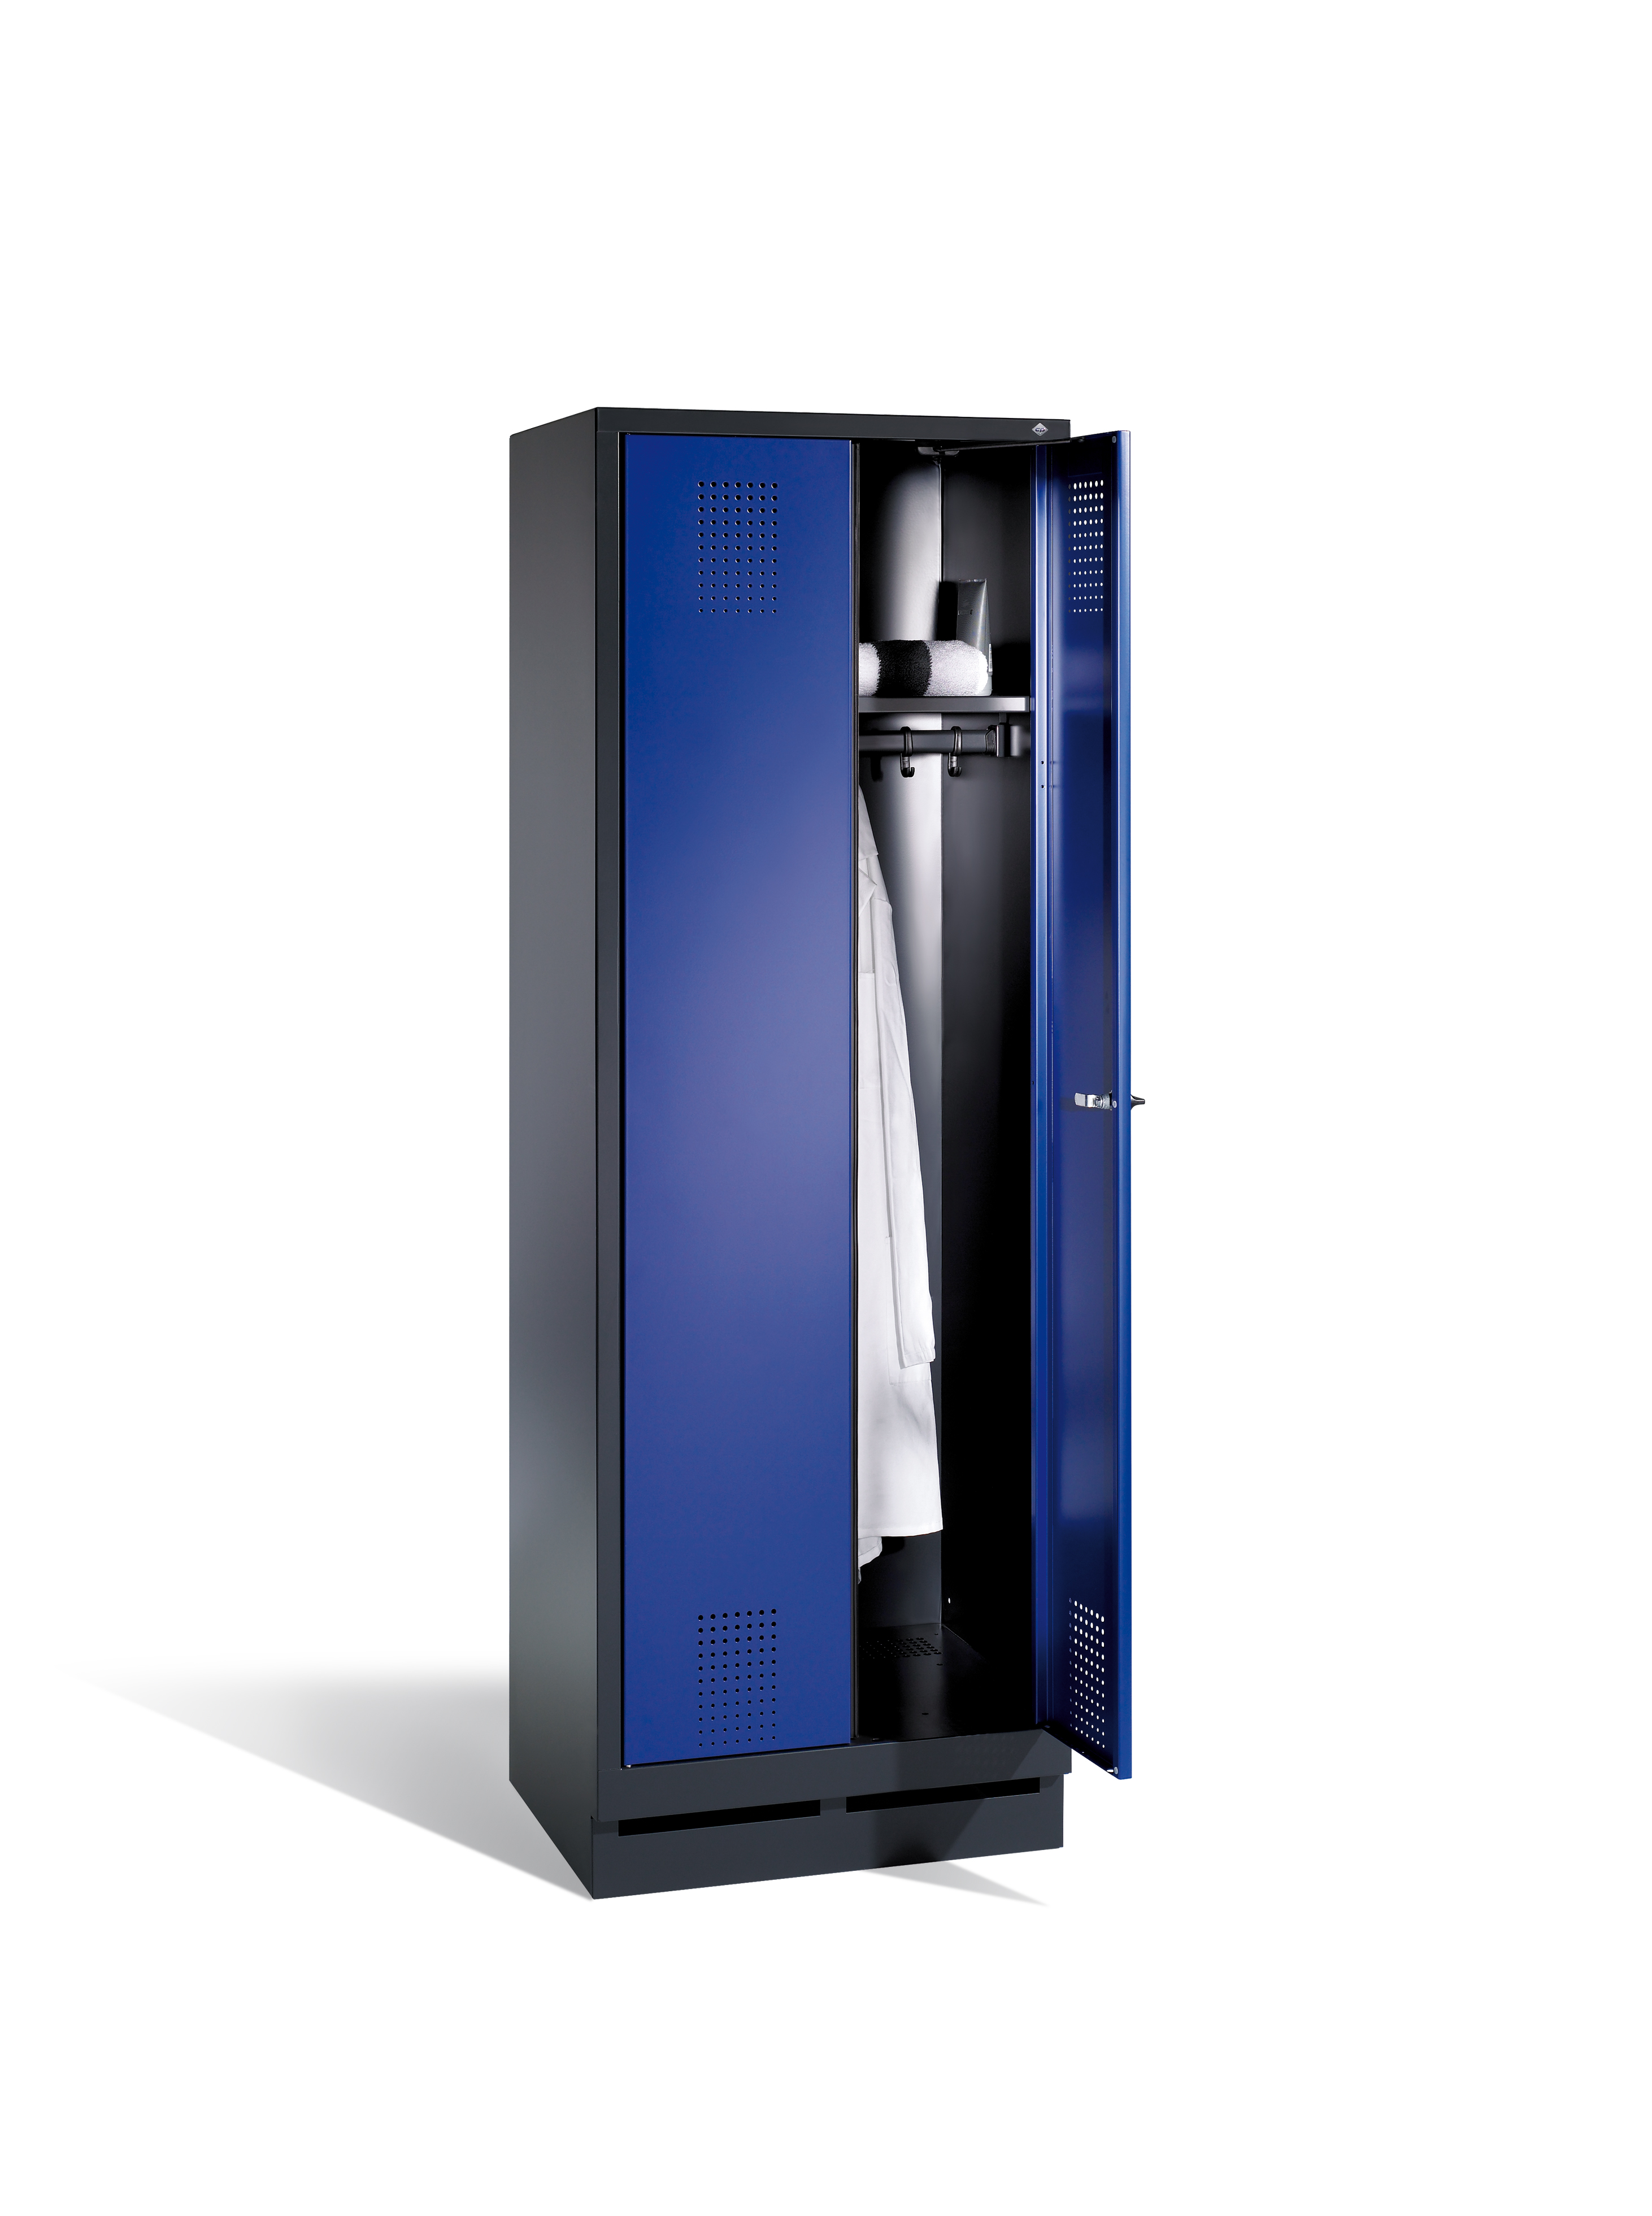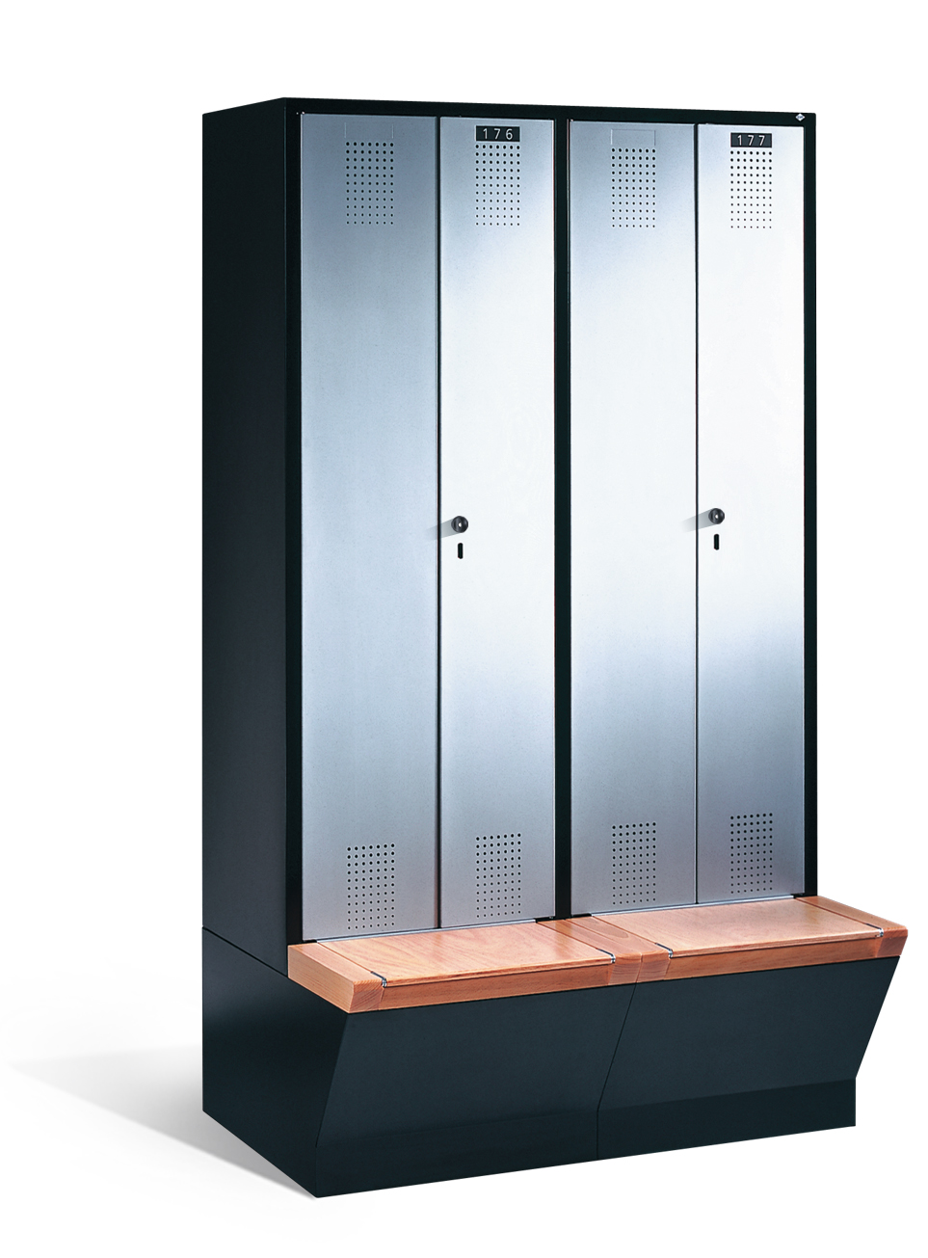

  - MANUFACTURER
C + P Möbelsysteme GmbH & Co. KG, Breidenbach, Germany with US Headquarter, CP Furniture Systems, Inc., 222 Merchandise Mart Plaza, Suite 10-166, Chicago, IL 60654

  - MATERIAL
    - ASTM A 1008 cold rolled steel sheet doors, bodies and accessories
    - Zinc plated bolts, rivets, nuts, and interior equipment.
    - Liquid or Powder coat Finish on steel sheet bodies, doors, and accessories.
      - Surface Preparation: Clean and treat locker components with multi-step detergent/iron phosphate coating, rinse with cold water, and seal with non-chrome treatment.
      - Finish Coat: Apply finish topcoat of 1-1.2mm thick high-solids polyester paint over primer with electrostatically charged dipping/spray process.
      - Paint exposed and concealed parts the same color.
      - Paint corrosion resistant. UV resistant upon request

  - BODIES
    - Tops and bottoms with three sides formed 90 degrees for strength, the front offset formed to be flush with horizontal frame member.
    - Sides to be formed with intermediate stiffener ribs.
    - Shelves with four sides formed to 90 degrees
    - All parts on assembled lockers shall be securely welded.

    - Tops and bottoms are to be a single piece for the entire locker grouping with three sides formed at 90 degrees and the front is to be channel formed and welded to each vertical frame member.
    - Backs are to be a single piece for the entire group of lockers.
    - Fully framed lockers shall provide structural resistance to force in all three planes.
    - Body, Frame & Door colors (RAL or RDS) to be specified on drawings
    - All colors according to ASTM D523, specular gloss measured on a 60 degree angle

  - DOOR CONSTRUCTION
    - Evolo Locker Doors stamped from one single, solid piece of steel, single walled, reinforced. Corners are folded into each other, thus highly warp resistant. All corners are rounded.
    - Door to be fitted with limiter to be set to 90 degrees angle and stop silencer (or optionally without limiter, then opening to 110 degrees)
    - Door opening to the right with hinges pins

  - FRAME
    - Locker (standard config.) 1,2,3,4,or 5 tier
Locker with bench in front 1 tier
Locker with lowered bench underframe 1 tier
Locker with bench underneath 1 tier
Locker with doors closing in center 1 tier
Locker with pairs of doors closing in center 1 tier
Locker with one door over two compartments 1 tier
Laundry & cleaning locker 1 tier
Combination locker 1 tier
Locker with wardrobe 3,4 or 5 tier
Top locker 1 tier
Top locker with doors closing in center 1 tier
Laundry/dispensing locker 1 tier (5,10,20 doors)

    - Measurements:
Standard configuration locker: 1850mm high; 500mm deep; 1x1 frame 320 or 420mm wide, 2x1 frame 610 or 810mm wide, 3x1 frame 900 or 1200mm wide, 4x1 1190mm or 1590mm wide, 5x1 1480mm wide; 2x2 frame 610 or 810mm wide, 3x2 frame 900 or 1200mm wide, 4x2 1190mm or 1590mm wide; 1x3 frame 320 or 420mm wide, 2x3 frame 610 or 810mm wide, 3x3 frame 900 or 1200mm wide, 4x3 1190mm wide; 1x4 frame 320 or 420mm wide, 2x4 frame 610 or 810mm wide, 3x4 frame 900 or 1200mm wide, 4x4 1190mm wide; 1x5 frame 320 or 420mm wide, 2x5 frame 610 or 810mm wide, 3x5 frame 900 or 1200mm wide, 4x5 1190mm wide.
Lockers with bench in front: 1850mm high, 500mm deep; 1x1 320 or 420mm wide, 1x2 610 or 810mm wide, 1x3 900 or 1200mm wide, 1x4 1190mm or 1590mm wide, 1x5 1480mm wide. Bench: 420mm high x 315mm deep
Lockers with lowered bench underframe: 1850mm high; 500mm deep; 1x1 320 or 420mm wide, 2x1 610 or 810mm wide, 3x1 900 or 1200mm wide, 4x1 1190 or 1590mm wide, 5x1 1480mm wide. Bench: 420mm high x 315mm deep
Lockers with bench underneath: 2090mm high; 500mm deep; 1x1 320 or 420mm wide, 2x1 610 or 810mm wide, 3x1 900 or 1200mm wide, 4x1 1190 or 1590mm wide, 5x1 1480mm wide. Bench: 420mm high x 315mm deep
Lockers with doors closing in center: 1850mm high; 500mm deep; 1x1 610 or 810mm wide, 2x1 1190 or 1590mm wide. Also available with bench in front and lowered bench underframe, same measurements as above.
Lockers with pairs of doors closing in center: available with bench option only. 2090mm high; 500mm deep; 1x1 610 or 810mm wide, 2x1 1190 or 1590mm wide. Bench (open): 420mm high x 315mm deep. Bench (closed, storage box): 452mm high x 315mm deep.
Lockers with one door over two compartments: On feet (150mm high) 1850mm high; 500mm deep; 1x1 610mm wide, 2x1 1190mm wide. On base (100mm high) 1800mm high; 500mm deep; 1x1 610mm wide, 2x1 1190mm wide. With Bench underneath: 2090mm high; 500 deep; 1x1 610mm wide, 2x1 1190mm wide.
Laundry & cleaning lockers: On feet (150mm) 1850 high; 500mm deep; 1x1 610 or 810mm wide (2x300 or 2 x400mm compartments). On base (100mm) 1800mm high; 500mm deep; 610 or 810mm wide (2x300 or 2 x400mm compartments).
Combination lockers: On feet (150mm) 1850mm high; 500mm deep; 1x1 & 1x2 combined 810mm wide (2x400mm compartments), 1x1 & 1x2 & 1x1 combined 1200mm wide (3x400mm compartments). On base (100mm) 1800mm high; 500mm deep; 1x1 & 1x2 combined 810mm wide (2x400mm compartments), 1x1 & 1x2 & 1x1 combined 1200mm wide (3x400mm compartments). With bench underneath: 2090mm high; 500mm deep; 1x1 & 1x2 combined 810mm wide (2x400mm compartments), 1x1 & 1x2 & 1x1 combined 1200mm wide (3x400mm compartments).
Lockers with wardrobe in center: 1850mm high; 1590mm wide (overall) 300 or 400mm width for compartments; compartments available in 3,4 or 5tier configurations
Top lockers (to be added on top of other configurations): 500mm high; 500mm deep; 1x1 320 or 420mm wide, 2x1 510 or 810mm wide, 3x1 900 or 1200mm wide, 4x1 1190 or 1590mm wide, 5x1 1480mm wide. Top lockers with doors closing in the center: 500mm high; 500mm deep; 1x1 610 or 810mm wide, 2x1 1190 or 1590mm wide
Laundry collecting/dispensing lockers: On feet (150mm) 1850mm high; 500mm deep; 5 or 10 door 420mm wide, 10 or 20 doors 810mm wide, 1 large door with swing flap 420mm wide. On base (100mm) 1800mm high, rest same as above
Custom sizes (limited to 2000mm h & 1600mm W)
    - Net locker measurements (per door):
Standard locker: 1tier 1600mm H x 230/330mm W x 465mm D; 2 tier 813mm H x 230/330mm W x 465mm D; 3 tier 510mm H x 230/330mm W x 465mm; 4 tier 375mm H x 230/330mm W x 465mm; 5 tier 295mm H x 230/330mm W x 465mm
Locker with bench in front: 1315mm H x 230/330mm W x 465mm
Locker with lowered bench underframe: 1315mm H x 230/330mm W x
465mm
Locker with bench underneath: 1600mm H x 230/330mm W x 465mm
Locker with doors closing in center: 1600mm H x 230/330mm W x
465mm
Locker with pairs of doors closing in center: 1600mm H x
230/330mm W x 465mm
Locker with one door over two compartments: 1600mm H x 230/330mm
W x 465mm
Combination locker: 1600/813mm H x 330mm W x 465mm
Locker with wardrobe: 3 tier 510mm H x 230/330mm W x 465mm; 4
tier 375mm H x 230/330mm W x 465mm; 5 tier 295mm H x 230/330mm W
x 465mm
Top locker: 430mm H x 230mm W x 465mm
Top locker with doors closing in center: 430mm H x 230mm W x
465mm
Laundry/dispensing locker: 5 doors 269mm H x 251mm W x 475mm; 10
door (420 width) 126mm H x 251mm W x 475mm; 10 door (810mm width)
269mm H x 251mm W x 475mm; 20 doors 126mm H x 251mm W x 475mm
    - Locker to come with feet (150mm high) with 40mm individual height adjustment (up to 190mm high). Or full base – 100mm high with approx. 60mm adjustment

  - DOOR LOCKS
    - Standard to be safety turning bolt for padlock use
    - Optional available locks (specify on drawings):
      - Cylinder lock with 2 keys
      - Coin/token operated lock

  - LOCKER VENTILATION
    - Ventilation in front through doors and base of locker

  - LOCKER FINISH/OPTIONS
    - Standard front: steel in many different colors (RAL or RDS) to be
specified on drawings
Standard interior fit:
Standard config. locker, locker with bench in front, locker with
lowered bench underframe, locker with bench underneath: Hat
shelf, coat rail & 3 hooks; 2 tier: coat rail & 3 hooks
Locker with doors closing in center: hat shelf across 2
compartments, coat rail with 3 hooks
Locker with pairs of doors closing in center: hat shelf across 2 compartments, coat rail with 3 hooks
Locker with one door over two compartments: 2 compartments with hat shelf & coat rail with 3 hooks each
Laundry & cleaning locker: 4 shelves on the left, hat shelf with coat rail and 3 sliding hooks on the right (laundry); 4 compartments to the left of shortened partition, rail with 6 sliding hooks on the right (cleaning); laundry storage lockers with individually lockable doors (hinged right), with doors closing in the center (joint lock), or with doors closing in center without partition, 4 full-width shelves
Combination locker: 1 tier coat rail and 3 sliding hooks; 2 tier coat rail and 3 sliding hooks
Locker with wardrobe: 3,4 or 5 tier: hat shelf, coat rack & shoe rack in between 2 locker compartments (open)
    - Standard bench in beech wood with clear varnish, 60mm x 35mm (3
slats
total), or plastic in white, light gray, dark gray or black gray
    - Standard door finish smooth
    - Optional door finish: stamped rosette hole pattern (steel doors
only) or perforated steel (models 48010-48090 only)- square
perforations
    - Optional front finish available in MCPB (Melamine Coated Particle
Board) in 18mm thickness; phenolic (HPL) 13mm thick –
color/finish to be specified on drawings, see CP Furniture
Systems, Inc.’s current catalog for color/finish options
    - Optional storage bench top available in beech wood (sides can be
optionally finished in beech)
    - Optional middle or end reveals: Center gap reveal available in
steel adjustable for gaps 30-45mm, 40-55mm, 50-65mm, 60-75mm, 70 - 85mm, 80-95mm, 90-105mm, 100-115mm and fixed in 110mm, 145mm, 180mm, 215mm, 250mm widths or custom; Inside corner (90 degrees) available in steel in 110mm, 145mm, 189mm, 215mm, 250mm widths or custom; Outside corner (90 degrees, 2x 45 degrees)available in steel in 500mm or custom; other materials available in custom only. Available for sloping tops also. End reveals: Full face mirror with options of 2 LED lighting strips on either side and LED lighting strip and 2 electrical outlets, single row 500mm W x 1700mm H, Double row 1000mm W x 1700mm H; also available with 2 electrical outlets and tray
    - Optional accessories (please specify on drawings): additional
partitions (in steel, transparent plastic, linen), additional
shelves, inside mirror (110mm x 90mm or 180mm x 300mm), towel
holder (on right), towel holder and shower gel holder on right,
sandal holder, laundry bags
    - Optional top of locker (bag deposit), 200mm high; sloping top,
200mm high in the rear, available for all body widths, 21 degree angle integrated with locker body; sloping top, 230mm high in the rear, available for all
body widths (set on top of locker), 26 degree angle
    - Optional security compartment, location and lock system to be
specified on drawings
    - Optional Number plates (self-adhesive, plastic or S.S)

**************************************************************************
- PART 3 EXECUTION
**************************************************************************

  - EXAMINATION
    - Do not begin installation until substrates and bases have been properly prepared.
    - Substrate and bases are the responsibility of another installer; notify Architect of unsatisfactory preparation before proceeding.

  - INSTALLATION
    - Install metal lockers and accessories at locations shown in accordance with manufacturer's instructions.
    - Install lockers plumb, level, and square.
    - Anchor lockers to floor and wall according to manufacturer’s recommendation.
    - Secure adjoining locker units together to provide rigid installation.
    - Install sloping tops and metal fillers using concealed fasteners. Provide flush hairline joints against adjacent surfaces.
    - Install front bases between legs without overlap or exposed fasteners. Provide end bases on exposed ends.
    - Install benches by fastening bench tops to pedestals and securely anchoring to the floor using appropriate anchors for the floor material.

  - ADJUSTING AND CLEANING
Adjust doors and latches to operate without binding. Verify that latches and locks are operating satisfactorily. Verify that ADA lockers operate according to code.

-- End of Section --
SECTION 10 51 13

