DIVISION 10 - SPECIALTIES
SECTION 10 51 13
METAL LOCKERS
CP Furniture Systems, Inc. - Intro LINE (S4000)

This guide specification covers the general requirements for metal lockers for storage of personal belongings.

Show the following information on the drawings:
- Location, grade and size, quantity, and color of lockers (plans).
- Trim, accessories, and adjoining surfaces details (elevations).
- Mounting details and whether legs, base panels, or pre-built bases are required (details).

**************************************************************************
- PART 1 GENERAL
**************************************************************************

  - REFERENCES
    - External References:
      - ADAAG - Americans with Disabilities Act, Accessibility Guidelines.
      - ASTM A 1008 - Standard Specification for Steel, Sheet, Cold-Rolled, Carbon, Structural, High-Strength Low-Alloy and High-Strength Low-Alloy with Improved Formability.
      - ASTM D523 – Standard test method for specular gloss (similar to ISO 2813)
      - ADA parallel reach requirements. (for maximum accessibility)
      - ADA forward reach requirements. (for narrow reach areas)
    - Related Sections
      - Section 06 10 53 - Miscellaneous Rough Carpentry for securing lockers to bases and walls.
      - 03 30 53 - Miscellaneous Cast-in-Place Concrete for locker bases.

  - SUBMITTALS
    - Comply with 01 33 00 Submittal Procedures
    - Provide manufacturer’s product data
    - Shop drawings showing plan and elevation with clearance requirements, accessories and anchoring detail
    - Provide numbering system and lock control chart
    - Three manufacturer’s standard color charts suitable for color selection

  - DELIVERY, HANDLING, AND STORAGE
    - Storage: Store materials in clean, dry, indoor areas.
    - Handling: Protect materials and finish during handling and installation to prevent damage to lockers or adjacent work.

  - FIELD MEASUREMENTS
To ensure proper fits, make field measurements prior to the preparation of drawings and fabrication. Verify correct location.

  - QUALITY ASSURANCE
Provide lockers from a manufacturer with a minimum of 10 years experience with a similar product and with a eight (8) year warranty. Install by a crew with a minimum of 10 years experience with a similar product and with a one year warranty.

1.6 ALTERNATIVES
No alternatives will be allowed or considered

**************************************************************************
- PART 2 PRODUCTS
**************************************************************************

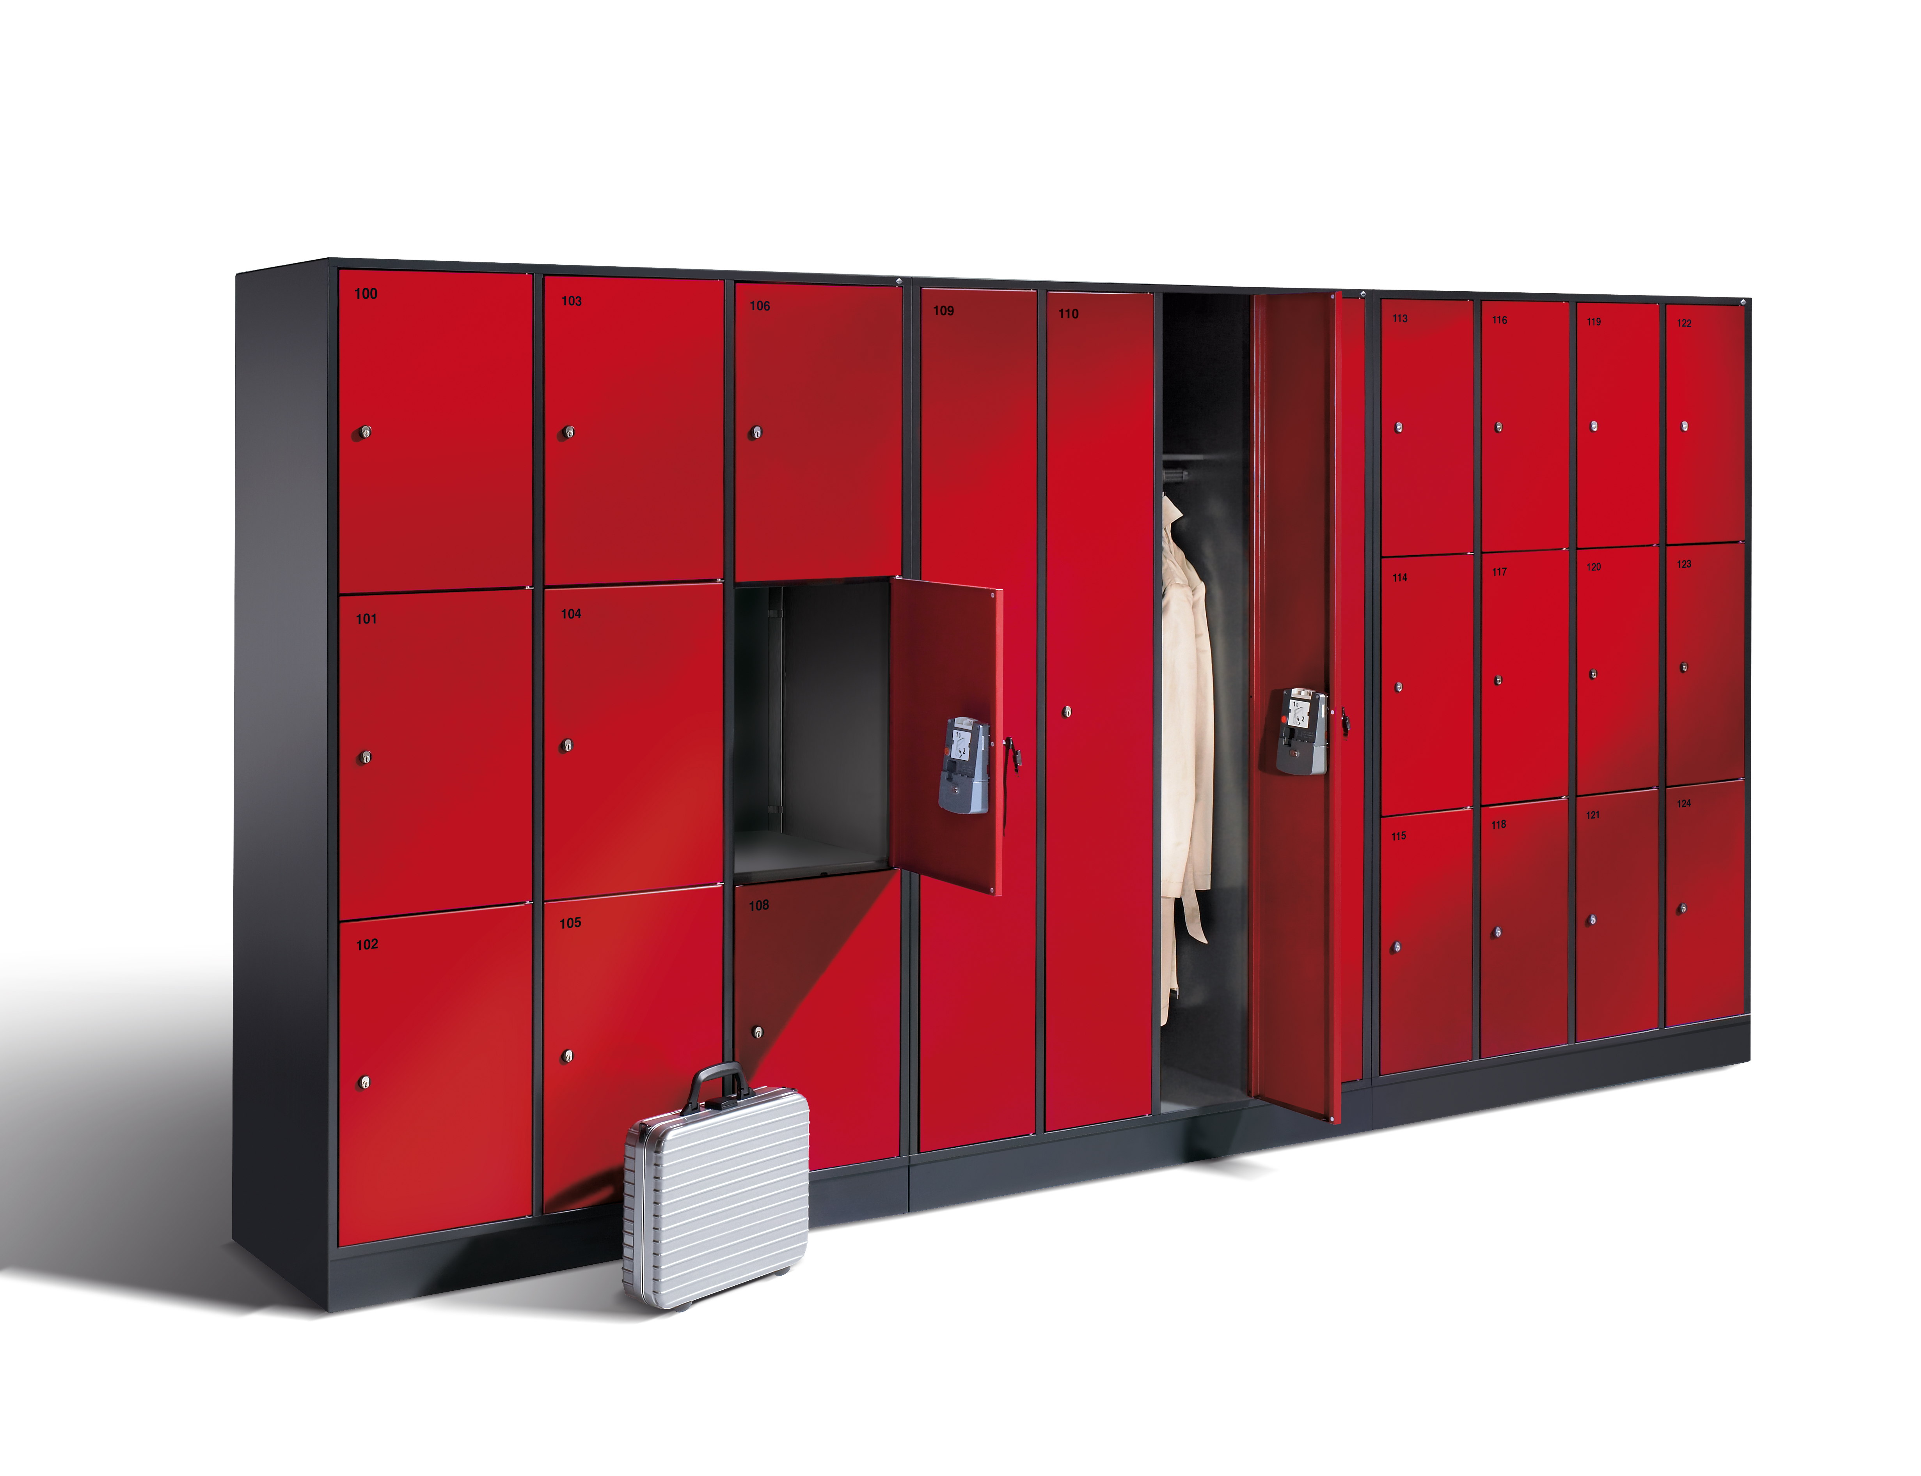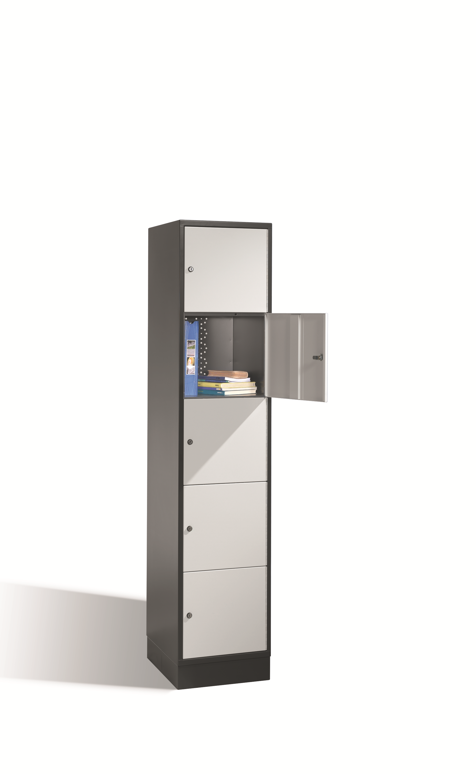

  - MANUFACTURER
C + P Möbelsysteme GmbH & Co. KG, Breidenbach, Germany with US Headquarter, CP Furniture Systems, Inc., 222 Merchandise Mart Plaza, Suite 10-166, Chicago, IL 60654

  - MATERIAL
    - ASTM A 1008 cold rolled steel sheet doors, bodies and accessories
    - Zinc plated bolts, rivets, nuts, and interior equipment.
    - Liquid or Powder coat Finish on steel sheet bodies, doors, and accessories.
      - Surface Preparation: Clean and treat locker components with multi-step detergent/iron phosphate coating, rinse with cold water, and seal with non-chrome treatment.
      - Finish Coat: Apply finish topcoat of 1-1.2mm thick high-solids polyester paint over primer with electrostatically charged dipping/spray process.
      - Paint exposed and concealed parts the same color.
      - Paint corrosion resistant. UV resistant upon request
  - BODIES
    - Tops and bottoms with three sides formed 90 degrees for strength, the front offset formed to be flush with horizontal frame member.
    - Sides to be formed with intermediate stiffener ribs.
    - Shelves with four sides formed to 90 degrees
    - All parts on assembled lockers shall be securely welded.

    - Tops and bottoms are to be a single piece for the entire locker grouping with three sides formed at 90 degrees and the front is to be channel formed and welded to each vertical frame member.
    - Backs are to be a single piece for the entire group of lockers.
    - Fully framed lockers shall provide structural resistance to force in all three planes.
    - Body, Frame & Door colors (RAL or RDS) to be specified on drawings
    - All colors according to ASTM D523, specular gloss measured on a 60 degree angle

  - DOOR CONSTRUCTION
    - Intro Locker Doors to be made from .88mm steel, stamped from one single, solid piece of steel.
    - 300mm wide: 1 and 2 tier lockers and extra large versions to have single walled door (reinforced),3,4,5, and 6 tier lockers to have double walled door. 400mm wide: 2,3,4,5 single walled door (reinforced) with option of double walled
    - Door able to open up to 170 degrees angle. Optional door opening limiter set to 90 degrees.
    - Door opening to the right with continuous steel hinge.
    - Doors available in standard steel or plexiglass upon request

  - FRAME
    - Intro Locker is available in:
Full height 1, 2, 3, 4, 5 or 6 tier configurations
Extra large 2, 3, 4, or 5 tier configurations
Half Height 3 tier
    - Measurements:
Full height: 1950mm high; 500mm deep; 1x2 frame (2 lockers) 620mm width, 1x3 frame (3 lockers) 920mm width, 1x4 frame (4 lockers) 1220mm width, 2x2 frame (4 lockers) 620mm width, 3x2 frame (6 lockers) 920mm width, 4x2 frame (8 lockers) 1220mm width, 2x3 frame (6 lockers) 620mm width, 3x3 frame (9 lockers) 920mm width, 4x3 frame (12 lockers) 1220mm width, 2x4 frame (8 lockers) 620mm width, 3x4 frame (12 lockers) 920mm width, 4x4 frame (16 lockers) 1220mm width, 2x5 frame (10 lockers) 620mm width, 3x5 frame (15 lockers) 920mm width, 4x5 frame (20 lockers) 1220mm width, 2x6 frame (12 lockers) 620mm width, 3x6 frame (18 lockers) 920mm width, 4x6 frame (24 lockers) 1220mm width
Extra large: 1950mm high; 500mm or 600mm depths; 2x2 frame (4 lockers) 820mm width, 3x2 frame (6 lockers) 1220mm width, 2x3 frame (6 lockers) 820mm width, 3x3 frame (12 lockers) 1220mm width, 2x4 frame (8 lockers) 820mm width, 3x4 frame (12 lockers) 1220mm width, 2x5 frame (10 lockers) 820mm width, 3x5 frame (15 lockers) 1220mm width
Half height: 1255mm high; 500mm deep; 2x3 frame (6 lockers) 620mm width, 3x3 frame (9 lockers) 920mm width
    - Net locker Dimensions:
Full height: 1 tier: 1825mm h x 260mm w x 460mm d, 2 tier: 895mm h x 260mm w x 460mm d, 3 tier: 580mm h x 260mm w x 460mm d, 4 tier: 435mm h x 260mm w x 460mm d, 5 tier: 345mm h x 260mm w x 460mm d, 6 tier: 285mm h x 260mm w x 460mm d
Extra large: 2 tier: 895mm h x 360mm w x 460mm/560mm d, 3 tier: 580mm h x 360mm w x 460mm/560mm d, 4 tier: 435mm h x 360mm w x 460mm/560mm d, 5 tier: 345mm h x 360mm w x 460mm/560mm d
Half height: 2/3 tier: 345mm h x 260mm w x 460mm d
    - Locker to come with plinth (100mm high) with 30mm individual height adjustment
  - DOOR LOCKS
    - Standard to be Cylinder lock with 2 keys
    - Optional available locks (specify on drawings):
      - Safety turning bolt for padlock use
      - Electronic Combination lock
      - Coin (token) operated lock
      - Custom, specify on drawings

  - LOCKER VENTILATION
    - Ventilation in rear of locker using a 20mm wall spacer

  - LOCKER FINISH/OPTIONS
    - Standard top finish with 25mm thick MCPB (Melamine Coated
Particle Board) for half height lockers only, specify on drawings
if needed
    - Standard front: steel in many different colors (RAL or RDS) to
be specified on drawings
    - Standard interior fit: Full height 1tier frame to include: 1 hat shelf, 1 coat rail with 3 hooks; 2tier frame to include: 1 coat rail with 3 hooks. Extra large 2tier frame to include 1 coat rail with 3 hooks.
    - Optional top finish available in glass or phenolic (HPL), or real
wood – color/finish to be specified on drawings, see CP Furniture
Systems, Inc.’s current catalog for color/finish options
    - Optional sloping top, approx. 230mm high in the rear, available
for all body widths, 26 degree angle
    - Optional Number plates (self-adhesive, plastic or S.S.)

**************************************************************************
- PART 3 EXECUTION
**************************************************************************

  - EXAMINATION
    - Do not begin installation until substrates and bases have been properly prepared.
    - Substrate and bases are the responsibility of another installer; notify Architect of unsatisfactory preparation before proceeding.

  - INSTALLATION
    - Install metal lockers and accessories at locations shown in accordance with manufacturer's instructions.
    - Install lockers plumb, level, and square.
    - Anchor lockers to floor and wall according to manufacturer’s recommendation.
    - Secure adjoining locker units together to provide rigid installation.
    - Install sloping tops and metal fillers using concealed fasteners. Provide flush hairline joints against adjacent surfaces.
    - Install front bases between legs without overlap or exposed fasteners. Provide end bases on exposed ends.
    - Install benches by fastening bench tops to pedestals and securely anchoring to the floor using appropriate anchors for the floor material.

  - ADJUSTING AND CLEANING
Adjust doors and latches to operate without binding. Verify that latches and locks are operating satisfactorily. Verify that ADA lockers operate according to code.
-- End of Section –
SECTION 10 51 13

