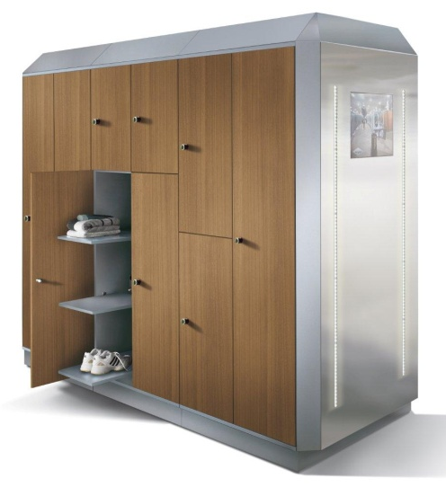
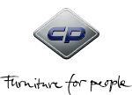
Specification sheet
S 7000 Prefino
A highlight –
for maximum requirements

Variations | Sub-frame | No. of compartments | Height | Compartment width | Depth
Full height lockers | Feet | 1-4 | 1950 mm | 300/400 mm | 500 mm
 | Plinth | 1-4 | 1950 mm | 300/400 mm | 500 mm
Double-tier lockers | Feet | 1-4 | 1950 mm | 300/400 mm | 500 mm
 | Plinth | 1-4 | 1950 mm | 300/400 mm | 500 mm
Assembled box lockers, 3-6 tiers | Feet | 1-4 | 1950 mm | 300/400 mm | 500 mm
 | Plinth | 1-4 | 1950 mm | 300/400 mm | 500 mm
Z lockers, Business-Class | Plinth | For 2 persons | 1950 mm | 600 mm | 500 mm

Construction details:
Carcass Durable sheet steel construction with multi-functional modular system and overlapping doors. Material thickness 0,88 mm
Spacious body height of 1850 mm (1950 mm incl. feet or base)
Body and steel doors electrolytically zinc-plated as a standard
Smooth interior walls – sanitary and easy to clean
Compartment sizes can also be retrofitted later
Sub-frame alternatively with feet, base, spacious storage box or bench
Optimum ventilation, alternatively through SVL (self-ventilation), FVL (forced ventilation), or FVLD concept (forced ventilation with dryer)

Doors Fronts made of steel, optionally HPL with wood decor or enameled glass for an even more attractive appearance. HPL decor doors available in white, silver gray, birch, cherry, and wengé or in REAL-wood veneer.
Door opening limiter 90° for outstanding closing characteristics as standard fittings

Interior Wide variety of interior fitting solutions for any requirement
Perforated hat shelf for improved ventilation
Coat rail with 4 double coat hooks and different positioning options for optimum adaptation to user behavior

Side panels Steel side panels for each visible outer surface is required. Mirror panels are also available.

Locks Cylinder lock with 2 keys as standard.

Colors C+P standard colors

Options:
Feet Height adjustment through adjustable plastic feet 100 mm high

Plinth Steel plinth, 100 mm. Approx. 60 mm height adjustment

Slanted roof Novel slanted roof (optional)

Bench Possibility for integrated bench, storage box, Ask for more details.

Locks Safety turning bolt latch for padlock,
Cylinder lock with or without master key system
Cylinder locks in moisture-proof design
Coin locks
Digilocks
Mechanical combination lock
Ask for other locking systems

Accessories Number plates, plastic key rings, wristband for keys, padlocks, additional interior fittings, different kind of door finish

Details and options:

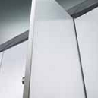 | Steel doors:  Double-walled and  insulated, 19 mm thick, offers unlimited color coating options. | 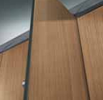 | HPL doors:  Made of high- pressure laminate, 13 mm thick  and available in a variety of  appealing decors.
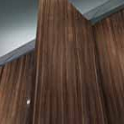 | Doors with real-wood veneer:  The right choice for sophisticated  surroundings. | 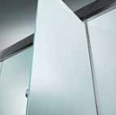 | Glass doors:  Sophisticated door variant made of  8 mm-thick, colourfully enamelled toughened safety glass.
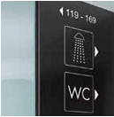 | Numbering and orientation:  Color matching inscriptions and pictograms are available to ensure optimal room orientation and numbering. | 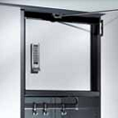 | Security compartment  Instead of the hat compartment.  Available for compartment widths of 300 and 400 mm.
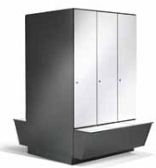 | Additional space:  The storage box allows you to take advantage of redundant space in the locker. | 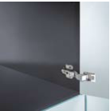 | Sanitary and easy to clean  Thanks to the smooth interior walls and bases, “dirty corners” are a concept unknown to Prefino.

