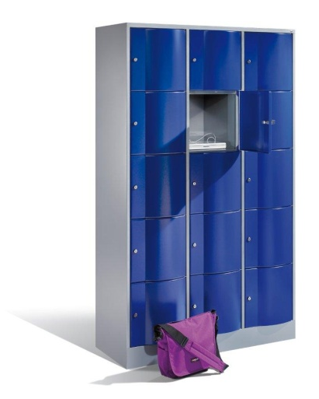
Specification sheet
S 5000 Resisto
The “vandal-resistant” lockers with special doors

Variations | Sub-frame | No. of compartments | Height | Locker width | Depth
Assembled box lockers, full-length doors, 1077 mm | Plinth | 2-3 | 1077 mm | 770/1150 mm | 540/640/740 mm
Assembled box lockers, 2 tiers, 1077 mm | Plinth | 2-3 | 1077 mm | 770/1150 mm | 540/640/740 mm
Assembled box lockers, 3 tiers, 1255 mm | Plinth | 2-3 | 1255 mm | 770/1150 mm | 540/640/740 mm
Assembled box lockers, 4 tiers, 1950 mm | Plinth | 1-3 | 1950 mm | 396/770/1150 mm | 540/640/740 mm
Assembled box lockers, 5 tiers, 1950 mm | Plinth | 1-3 | 1950 mm | 396/770/1150 mm | 540/640/740 mm
Extra-large assembled box lockers, 2 tiers, 1950 mm | Plinth | 1-3 | 1950 mm | 396/770/1150 mm | 540/640/740 mm
Extra-large combination assembled box lockers, 2 + 4 + 2 or 4 + 2 + 4 tiers, 1950 mm | Plinth | 1-3 | 1950 mm | 1150 mm | 540/640/740 mm
Extra-large combination assembled box lockers, 2 + 5 + 2 or 5 + 2 + 5 tiers, 1950 mm | Plinth | 1-3 | 1950 mm | 1150 mm | 540/640/740 mm
Open wardrobe | Plinth | 2 | 1950 mm | Total width: 1742 mm | 540 mm

Construction details:
Carcass Durable steel structure. Carcass made of 0,88 mm steel.
All compartments are easy to reach for children, making them ideal for use in schools and childcare facilities.
3 different depths: 540, 640, and 740 mm (absolute body depths 480, 580, and 680 mm). Depths of 640 and 740 mm ideally suited for storing large gym bags.
All lockers with attractive base, 100 mm high, in color of body and 30 mm height adjustment
All lockers with louvers in the rear panel and 20 mm wall spacer

Doors Special doors made of steel 1.5 mm thick, curved to the front, absolutely sturdy and “vandal-resistant”
Door hinged on right with sturdy strap hinges.
Door opening limiter 80° and wall mounting as standard features

Interior For lockers 1950 mm with 2 tiers each compartment has 1 coat rail with 3 sliding hooks.

MCPB Top Assembled box lockers with decor top made of MCPB (melamine coated particle board) For height 1077 mm and 125 mm.
Tops standard with 20 mm projection in the rear

Locks Cylinder lock with 2 keys as standard.

Colors C+P standard colors

Options:

Sloping top Available for the different depths and widths.

MCPB Top Tops without projection in the rear.

Locks Safety turning bolt latch for padlock,
Cylinder lock with or without master key system
Cylinder locks in moisture-proof design
Coin locks
Digilocks
Mechanical combination lock
Ask for other locking systems

Accessories Number plates, plastic key rings, wristband for keys, padlocks, additional interior fittings.

Details and options:

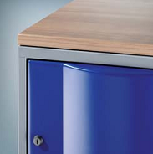 | Cover plate:  Durable DBS cover plates protect the top of the half-height lockers. | 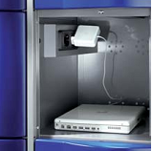 | Power supply:  As an option, each compartment can be fitted with two 230 V sockets to recharge laptops or mobile phones in no time.
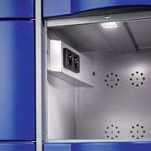 | Lighting:  Optional interior LED to light up even the darkest corners. | 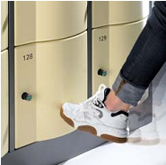 | Tamper proof:  The 1.5 mm curved steel doors make Resisto extremely sturdy.
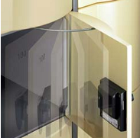 | Door opening limiter 80°:  Prevents damage to the door of the adjacent Resisto locker. Also available with automatic door closure.

